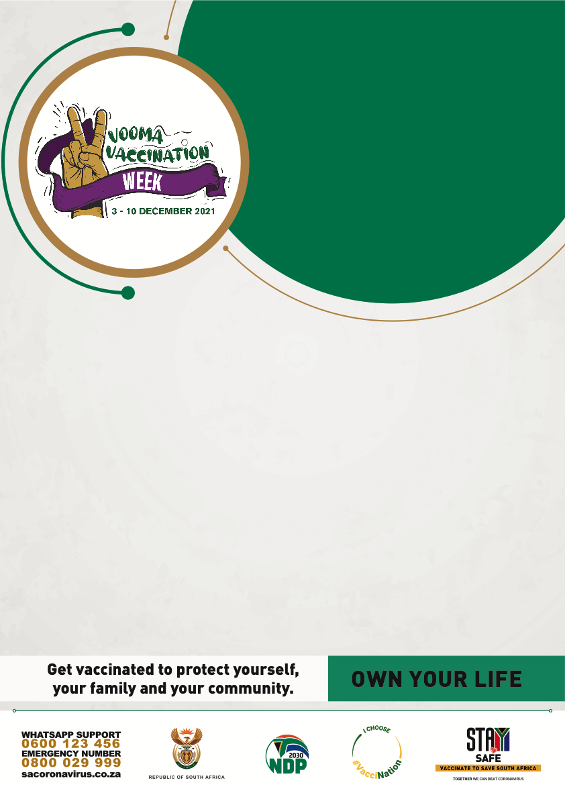

**The President has called on   
everyone to support the COVID-19   
vaccination programme.**

**Now’s your chance!**

**Be part of Vooma   
Vaccination Week**

**3-10 December 2021.**

**Come get your jab**

text here

Date: **XXXXXX**

Time: **08:00 – 09:00**

Venue: **XXXXXXXXXXXXX XXXX XXX**