DEVELOPMENT COMMUNICATION ACTIVITY NAME | Minister Muthambi hands over houses in Willowfontein, uMsunduzi Municipality KZN.
DATE OF THE EVENT | 13 December 2015
VENUE & AREA | Willowfontein, KwaZulu-Natal.
DC ACTIVITY SYNOPSIS:

In 2014, the Minister of Communications participated in the Presidential Imbizo which took place in Msunduzi Local Municipality on the 30th of September 2014. On this occasion, the Minister was able to engage communities in Ward 14 of uMsunduzi, many of whom had critical developmental needs, and some of which were indeed pertinent to the Communications Portfolio headed by Minister Muthambi. As part of the aftercare programme to the Presidential Imbizo, the Minister of Communications identified housing construction for destitute families as a key area of intervention. One of the milestone deliverables has been in partnership with Multichoice, where two houses have been built and furnished. The said houses have now been completed and were handed over to the two families of Mathe and Mkhize-Madondo respectively. The remainder of the three (3) houses have been be built by Msunduzi Local Municipality. This follows two previous follow-up visits by the Minister of Communications to the area where other needs identified during the Presidential Imbizo were addressed. A previous highlight was the opening of an ICT Center for computer raining for youth in this area as well. The construction of the additional houses is now 90% complete. The Minister of Social Development, Bathabile Dlamini accompanied the Minister Muthambi during the handover and provided a range of social and other support services to the families.

PHOTO TESTIMONIALS WITH CAPTIONS:

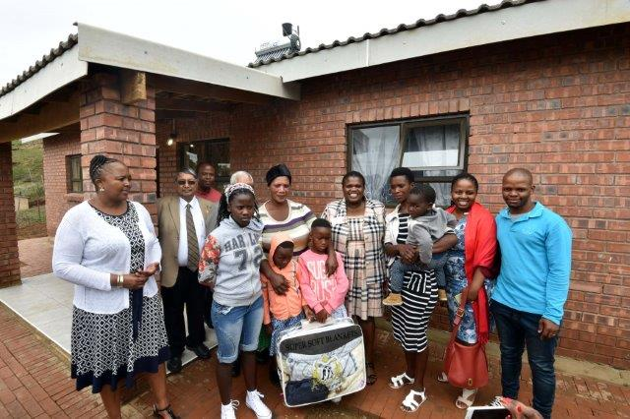
ABOVE: The Mkhize - Madondos are one of the beneficiaries that received a house by MultiChoice through Minister Muthambi’s intervention. Pictured above from Left: Ms Pearl Bhengu – KZN SASSA Executive Manager, Cllr Baijoo Baboo - Speaker of Msunduzi Municipality, the Mkhize-Madondo family, Minister Muthambi, Ms Ndala Mngadi - GCIS KZN Provincial Director and KZN Regional Communications Coordinator for this area Mr Mlungisi Dlamini.

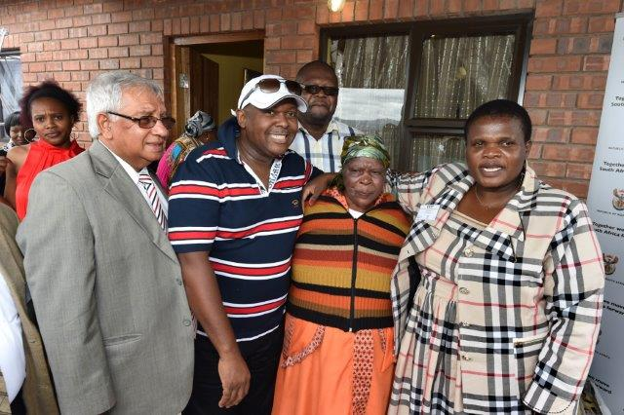
ABOVE: Minister Muthambi together with the uMngungundlovu District Municipality - Cllr Yusuf Bhamjee, MultiChoice General Manager for Regulatory Affairs – Mr Kwezi Mtengenya, Gogo Mathe – the beneficiary of the house and the at the back, DSD DG, Mr Magwaza.

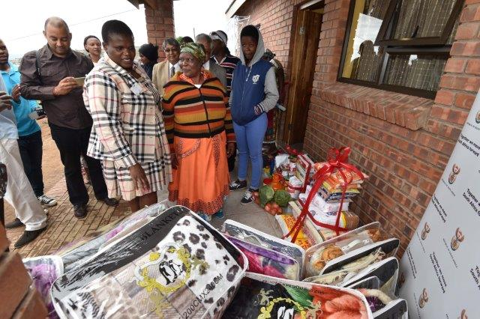
ABOVE: The groceries and the blankets that were given to the families.

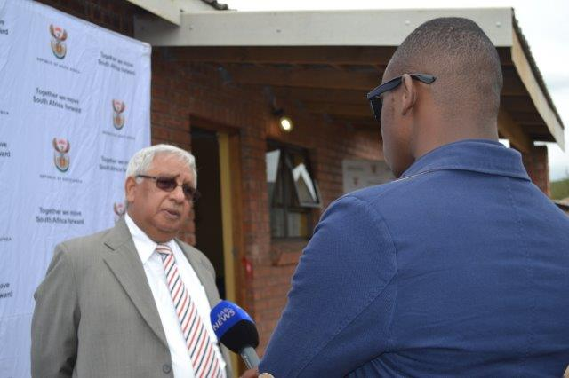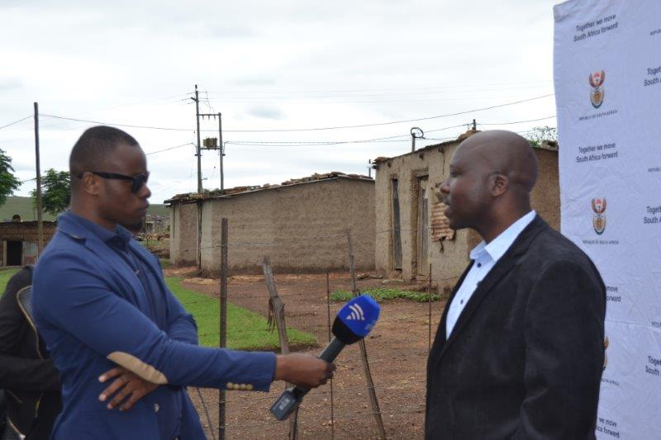
ABOVE – Left: uMngungundlovu District Municipality - Cllr Yusuf Bhamjee, being interviewed by SABC. Right – Ward 14, Willowfontein Councillor Mr Sibusiso Mkhize as he got interviewed by the SABC on the development in the area.

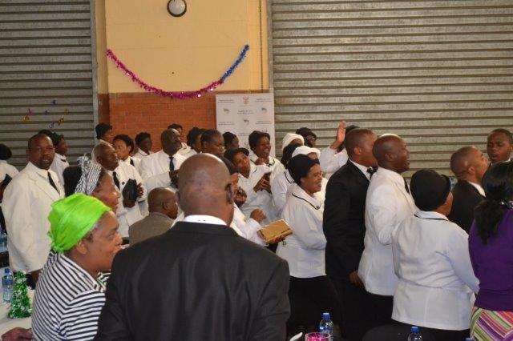
ABOVE: The Presbyterian Church – Willowfontein Branch was part of the event and pictured above is how they showed their appreciation and excitement of the development in the area.

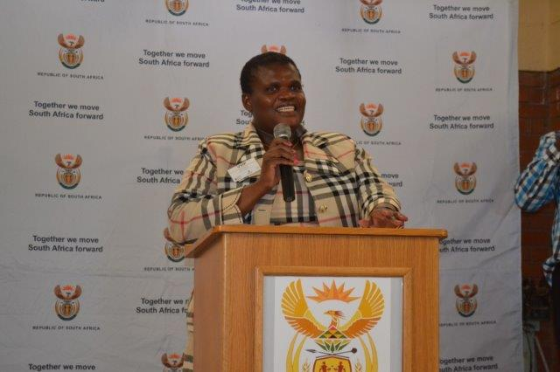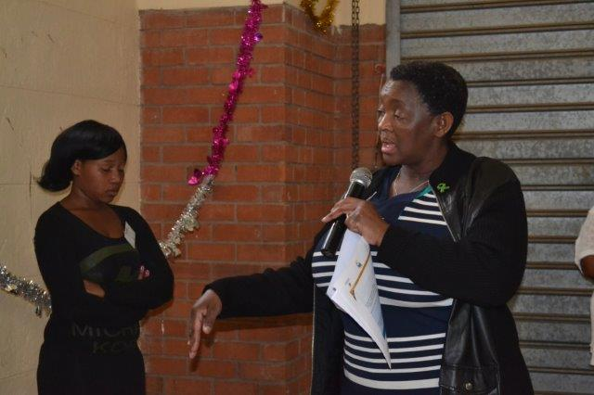

ABOVE
ABOVE: Ministers Faith Muthambi and Bathabile Dlamini as they address the community on the progress made in the area and interventions that the Department of Social Development will engage, all following the Presidential Imbizo which took place in this area in September 2014.

