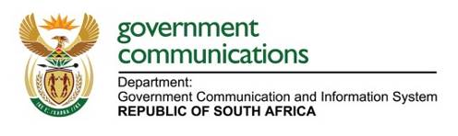

**PICTORIAL REPORT**

**Information Resource Center workers month and Gender Based Violence and Femicide Activation**

**09 May 2025: Hamanskraal, Tshwane, Gauteng**

On 09 May 2025, Government Communication and Information System (GCIS) Information Resource Center (IRC) and Tshwane team in partnership with the Hamanskraal clinic, Temba Police Gender Based Violence and Femicide (GBVF) and Community Policing Forum conducted GBVF campaign with some of lesbian, gay, bisexual, transgender, queer/questioning, and intersex. (LGBTQI) community of Hamanskraal to encourage them to report GBVF incidents to the authorities. The team also communicated the messages about GBVF, the importance of Knowing about GBVF and distributed information materials on GBVF and other Government publications to the members who were in attendance.

**Below:** Some of the pictures of GCIS officials and stakeholders sharing information with some of the community members who accessed the services.

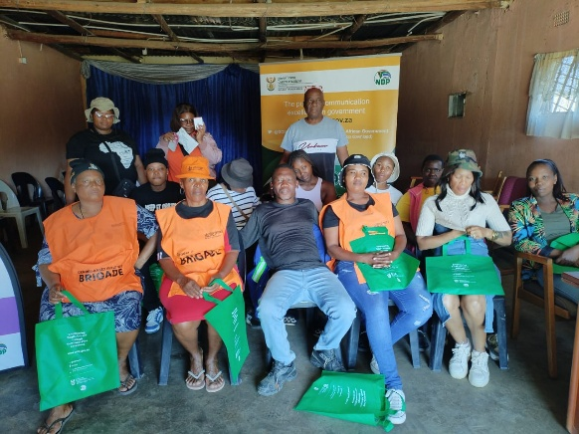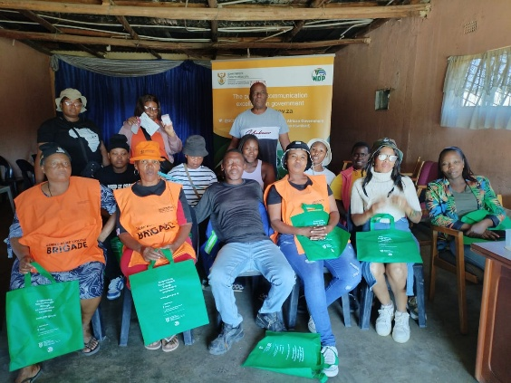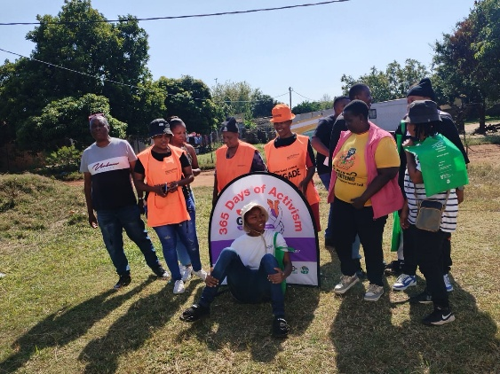

**GCIS officials, GBVF brigades, SANCO members, health officials and some of the LGBTQI community members posing for a picture.**

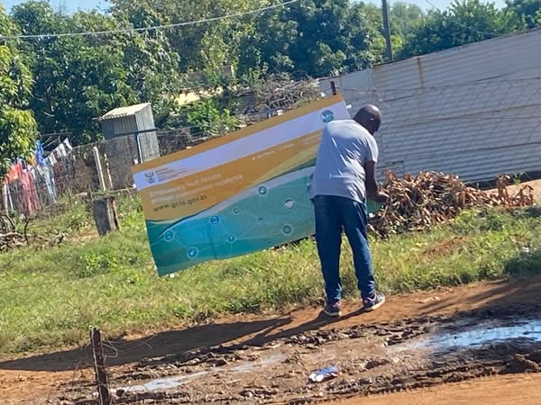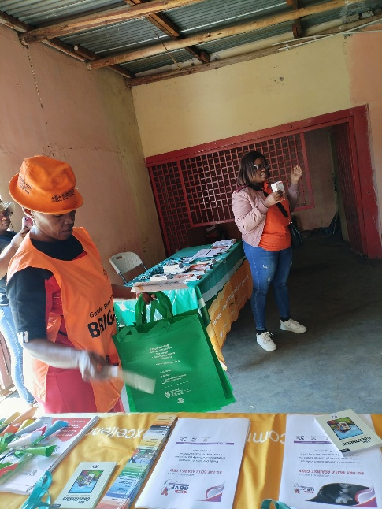

**George Moeketsi Grom GCIS Branding the street, GBVF Brigade packaging GBVF information materials and Health Officials communicating the importance of testing for HIV and using PREP.**

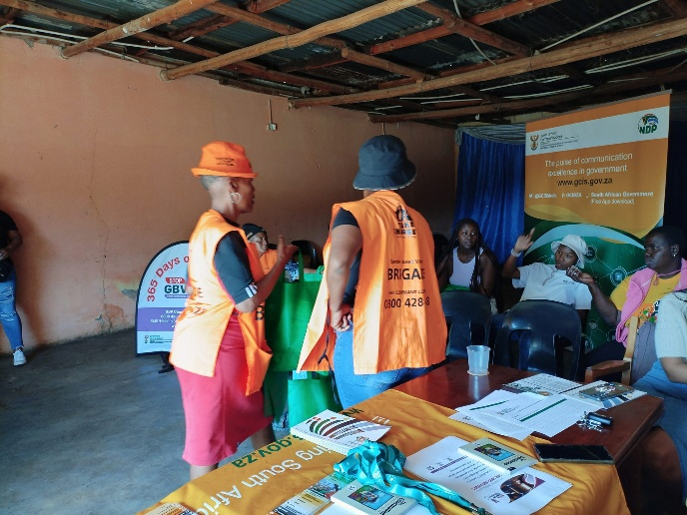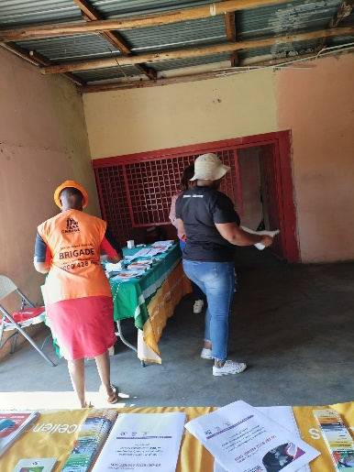 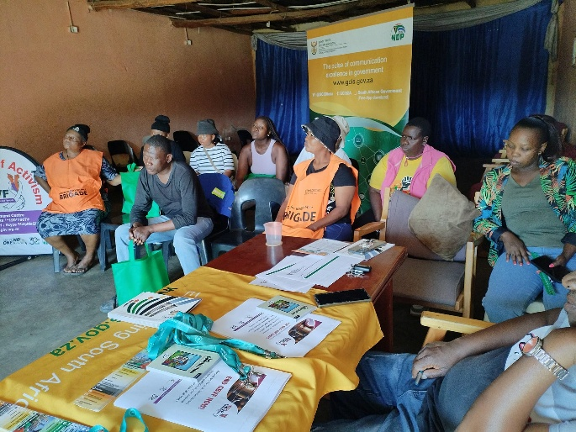

**Stakeholders and community members engaging with each other.**

mn