Deputy Minister for Energy, Ambassador Thembisile Majola, in Ntabankulu Municipality for her repeat visit in Ward 17 to address issues of electricity – 26 June 2015
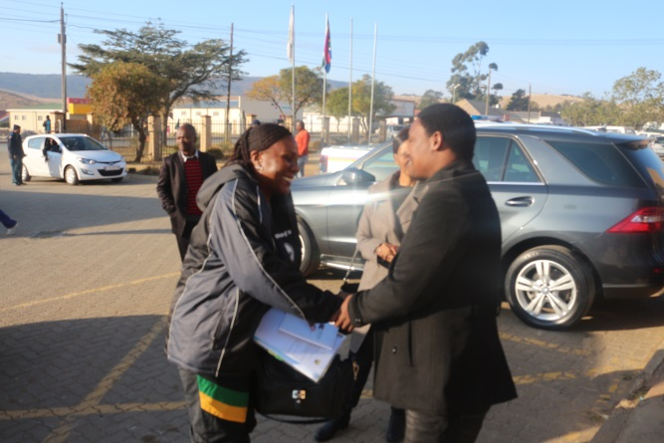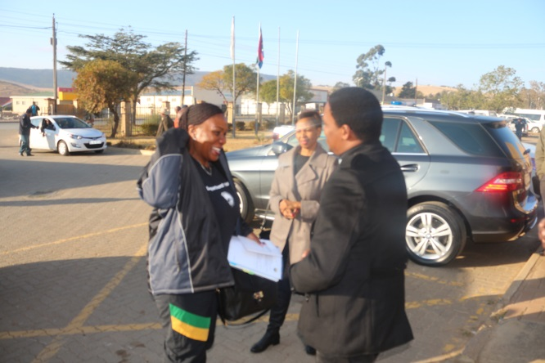
Deputy Minister arrives at Ntabakulu Municility and is welcomed by Mayor of Ntabankulu Municipality, Cllr Vusi Mgoduka

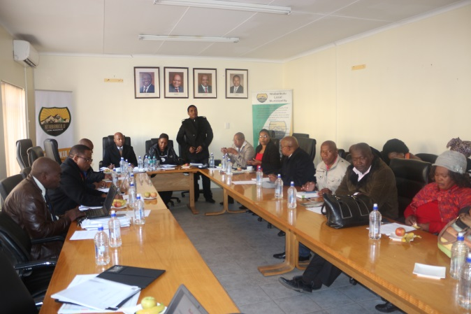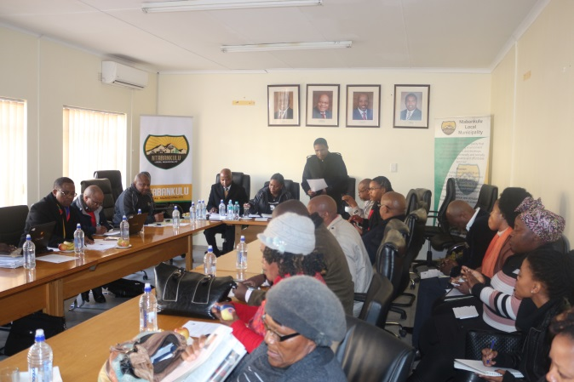
Stakeholder engagement session led by the Deputy Minister and the Mayor

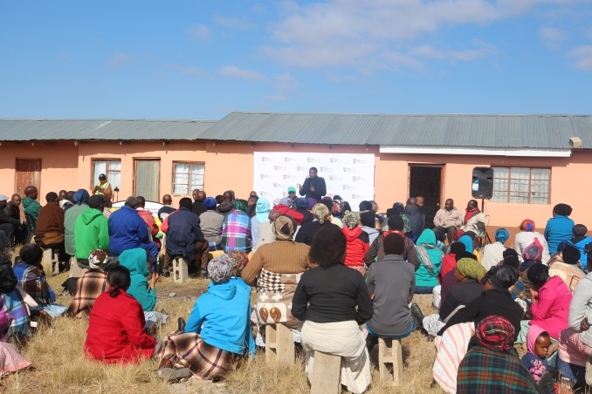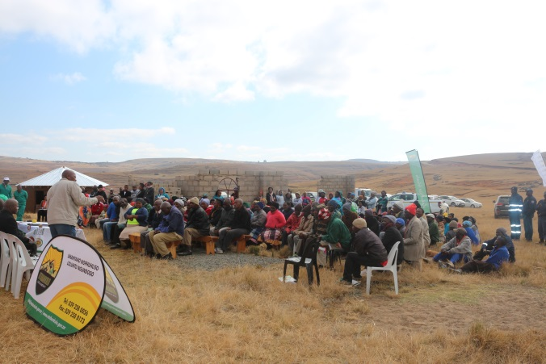
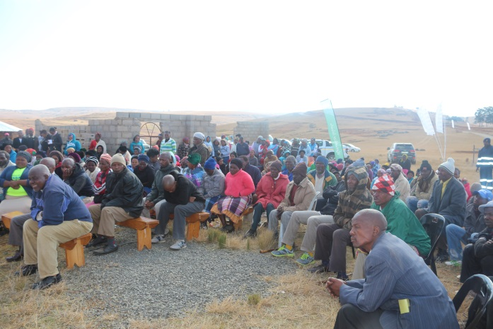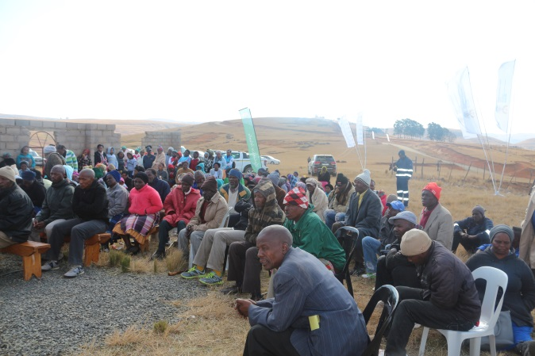
Community members of ward 17 in Ntabankulu gathered in Mbhongweni Village

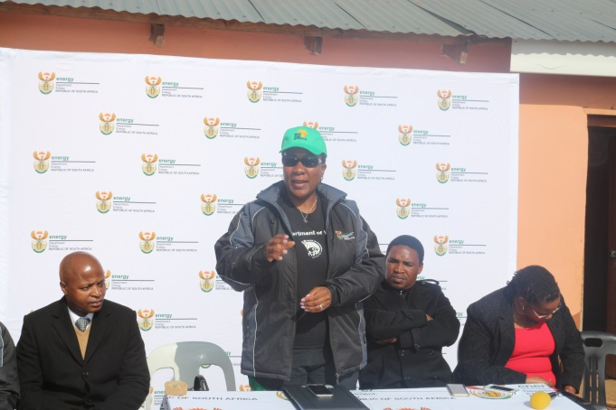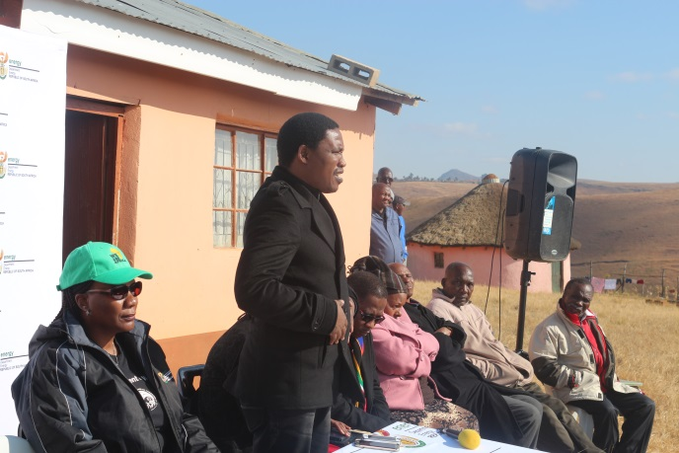
The Deputy Minister and Mayor addressing the community members

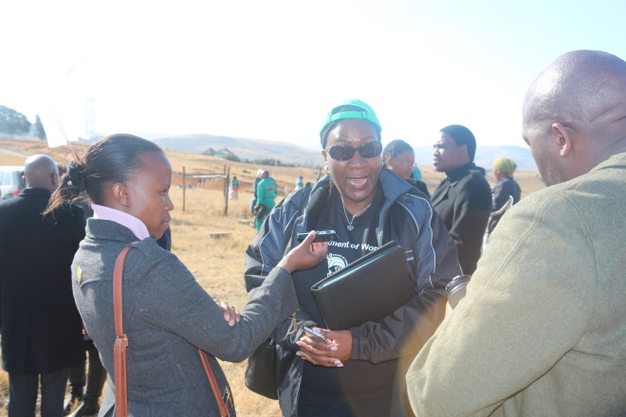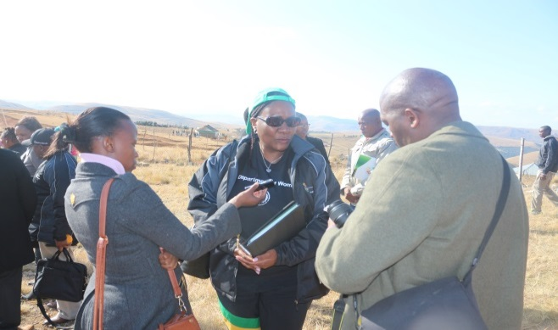
Post media interviews for both the Deputy Minister and the Mayor. Interviewed by Alfred Nzo Radio and Mthatha Fever respectively.
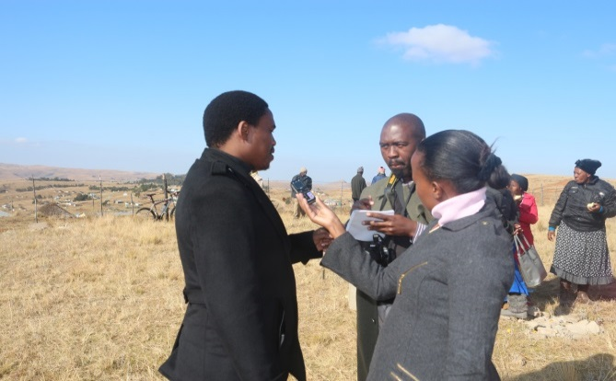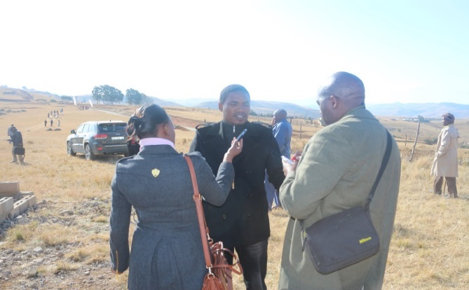
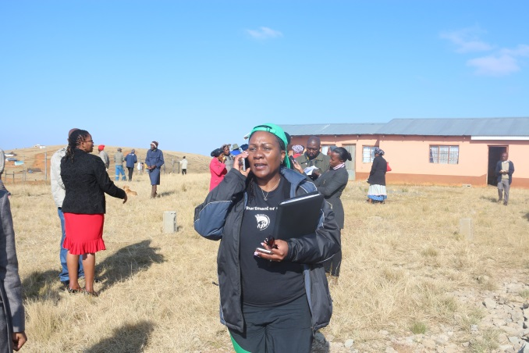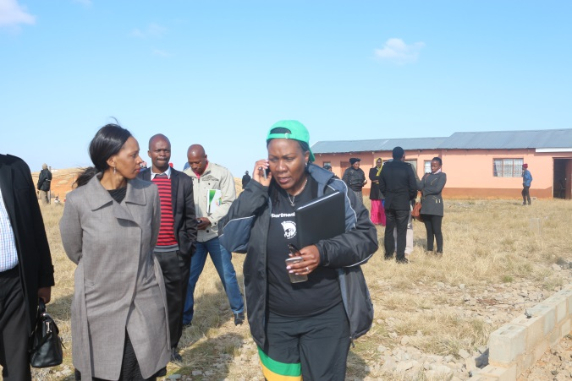
The Deputy Minister on a telephonic interview with Inkonjane FM

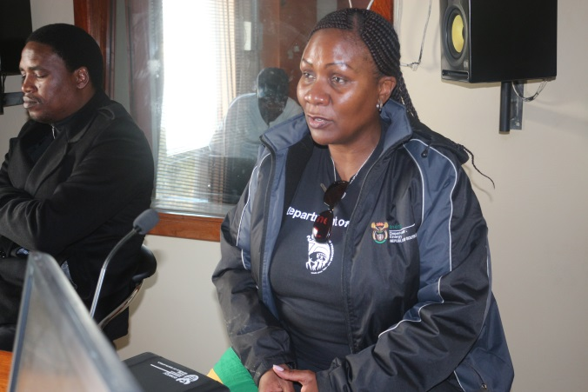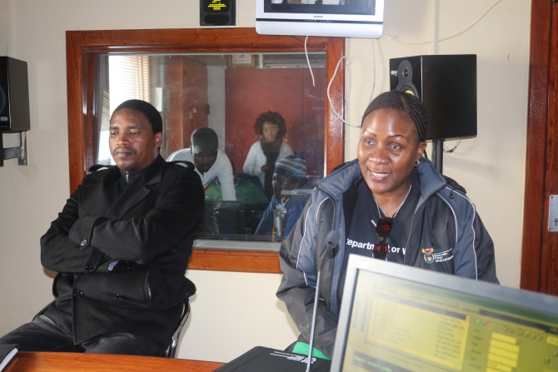
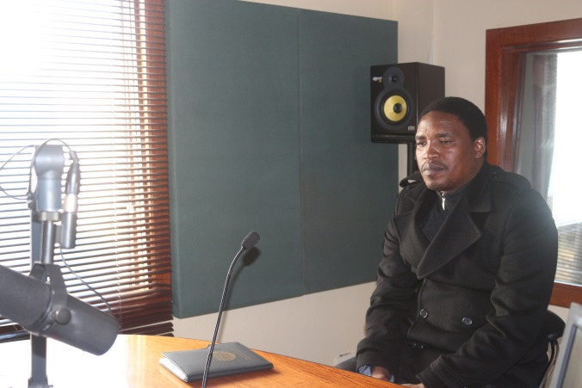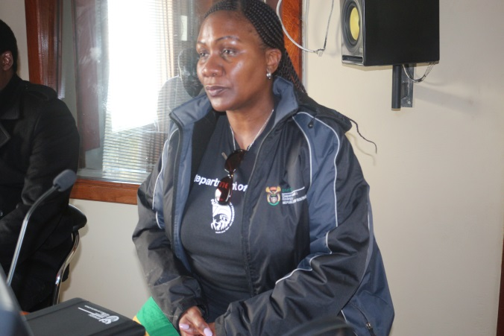
Post radio interview at Alfred Nzo Radio

